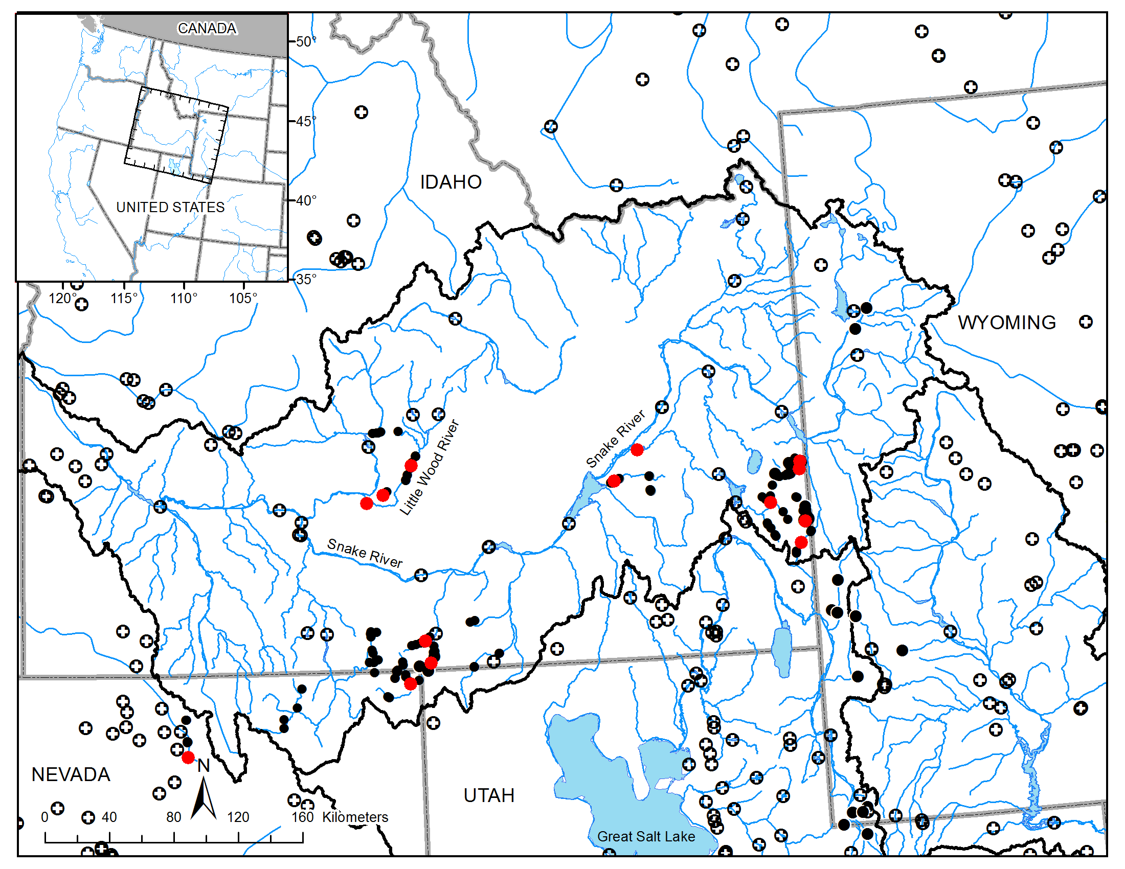
Supplemental Fig. 1. Collection locations for northern leatherside chub where specimens were deposited in museum collections (red circles) and examined by Keeley et al. (2012). Black circles indicate the location of all sampling locations attempting to find northern leatherside chub for the present study. Crossed-circles indicate the location of major dams within the western United States. Location data for dams are from the National Inventory of Dams (http://nationalatlas.gov/mld/dams00x.html). Inset map indicates the location of the area within the western United States.

